Activity Number: Language_CY_KSPNV_1
Title: Character in a box
Designed by: KSPNV
Area(s): (iii) Language(s)

Objectives:
- Demonstrate positive stances towards listening, reading and narrating folktales and other narrative texts, viewing the act of storytelling as an imaginative journey, but also as a way of interpreting real life.
- Apply reading and listening strategies to comprehend, analyse, and criticize a narrative text.
- Apply speaking strategies to present, in an attracting and convincing way, ideas and arguments, which pertain to the stories.
- Compare folktales and identify similarities and differences, in terms of the way in which they are structured and written.

Appropriate EUMOF stories:
All EUMOF stories

Materials needed:
The handout bellow

Age level(s): 8-12

Step-by-step description of activity:
- Teacher narrates the story.
- S/he has children fill in the handout presented below.
- Teacher shows the handout on a projector.
- Children share their answers and the teacher fills in the blanks on the projector.
- They then get in groups and do the same thing about a character in another EUMOF story.
- Each group presents their character and comparisons are made (similarities and differences).
- Conclusions are reached about the manner in which a character’s personality is revealed in a story.

What’s his/her name? .............................

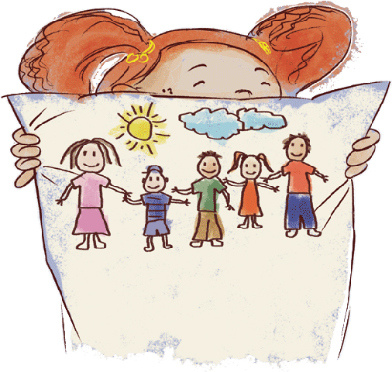
OTHER PEOPLE
Τhey tell him/her ............................................................................................................................................................................................................................................................................

They say about him/her ............................................................................................................................................................................................................................................................................

Draw a picture of the hero:
HIS/HER APPEARANCE
She/ He looks like .....................................................................................................................................................................................................................................................................................................................................................................................................................................................................................
WORDS AND REACTIONS
He/ She says ............................................................................................................................................................................................................................................................................
His/ Her reaction ..............................................................................................................................................................................................................................................................................

